DAILY ONLINE ACTIVITIES SUMMARY

|  |  |  |  |  |  |  |  |
| --- | --- | --- | --- | --- | --- | --- | --- |
| **Date:** | **9/06/2020** | | | | **Name:** | **Kavya.R.Shetty** | |
| **Sem & Sec** | **VI , A sec** | | | | **USN:** | **4AL17CS042** | |
| Online Test Summary | | | | | | | |
| **Subject** | | **CGV CNSC** | | | | | |
| **Max. Marks** | | **CGV - 30**  **CNSC - 60** | | **Score** | | **CGV – 20**  **CNSC - 40** | |
| Certification Course Summary | | | | | | | |
| **Course** | **EXCEL FOR BEGINNERS** | | | | | | |
| **Certificate Provider** | | | **GREATLEARNING** | **Duration** | | | **4.5HRS** |
| Coding Challenges | | | | | | | |
| **Problem Statement:**   1. Write a Python to implement Perfect Sum Problem 2. write a java Program to print smallest and biggest possible palindrome word in a given string 3. Python Program to count even and odd numbers 4. Write a Java Program to remove all white spaces from a string without using replace() | | | | | | | |
| **Status: Completed** | | | | | | | |
| **Uploaded the report in Github** | | | | **Yes** | | | |
| **If yes Repository name** | | | | <https://github.com/kavya-shetty765/DAILY-STATUS> | | | |
| **Uploaded the report in slack** | | | | **Yes** | | | |

# Online Test Details:

CGV

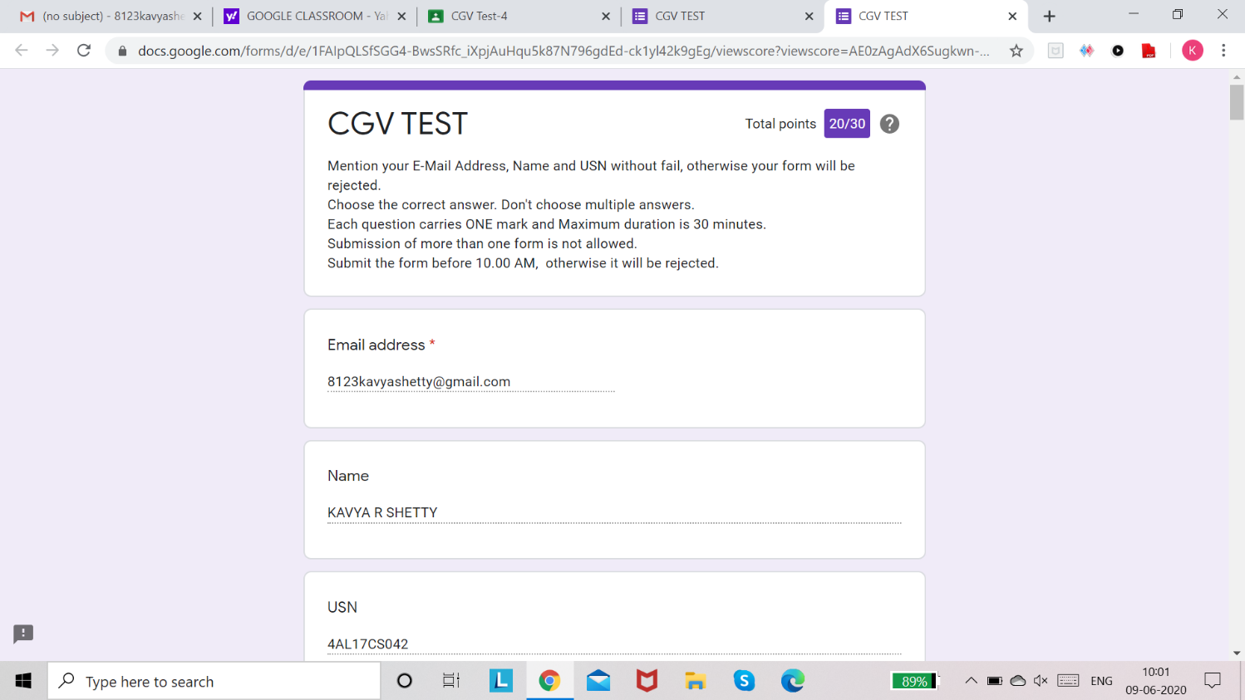

CNSC

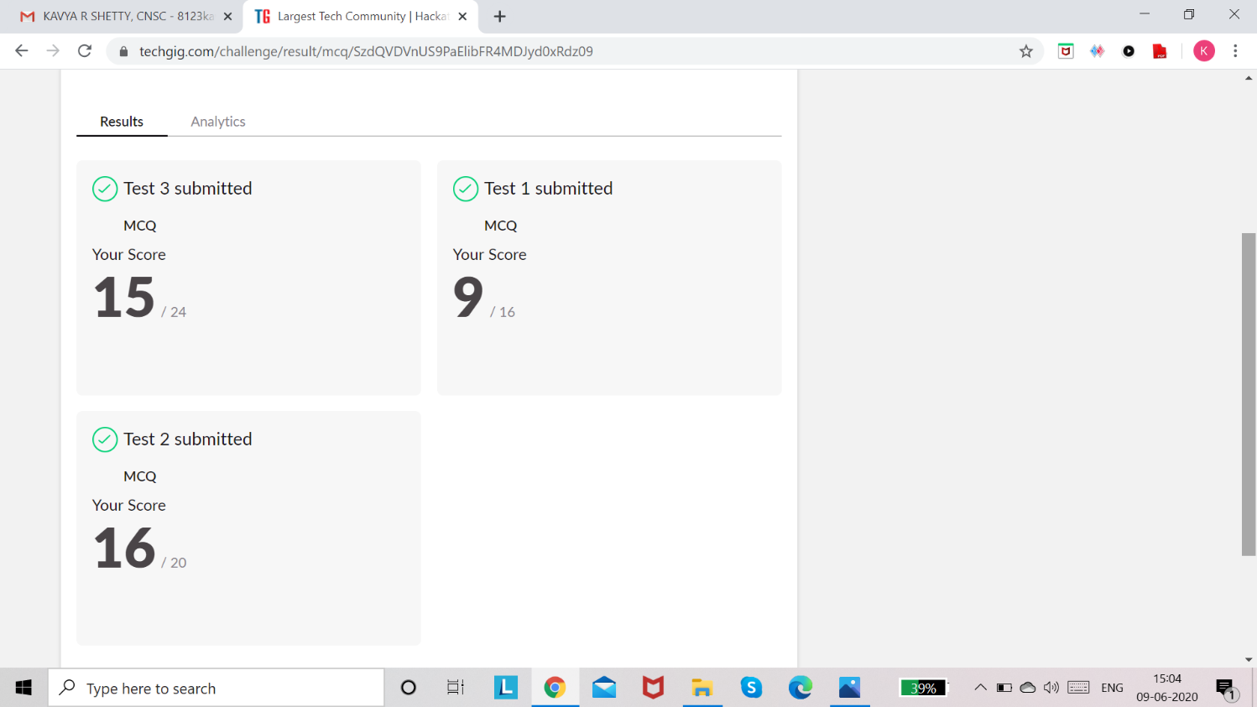

# Certification course Details:

**EXCEL FOR BEGINNERS**

<https://github.com/kavya-shetty765/DAILY-STATUS/tree/master/9-06-> [2020/CERTIFICATION%20COURSE](https://github.com/nandithashetty/DAILY-STATUS/tree/master/9-06-2020/CERTIFICATION%20COURSE)

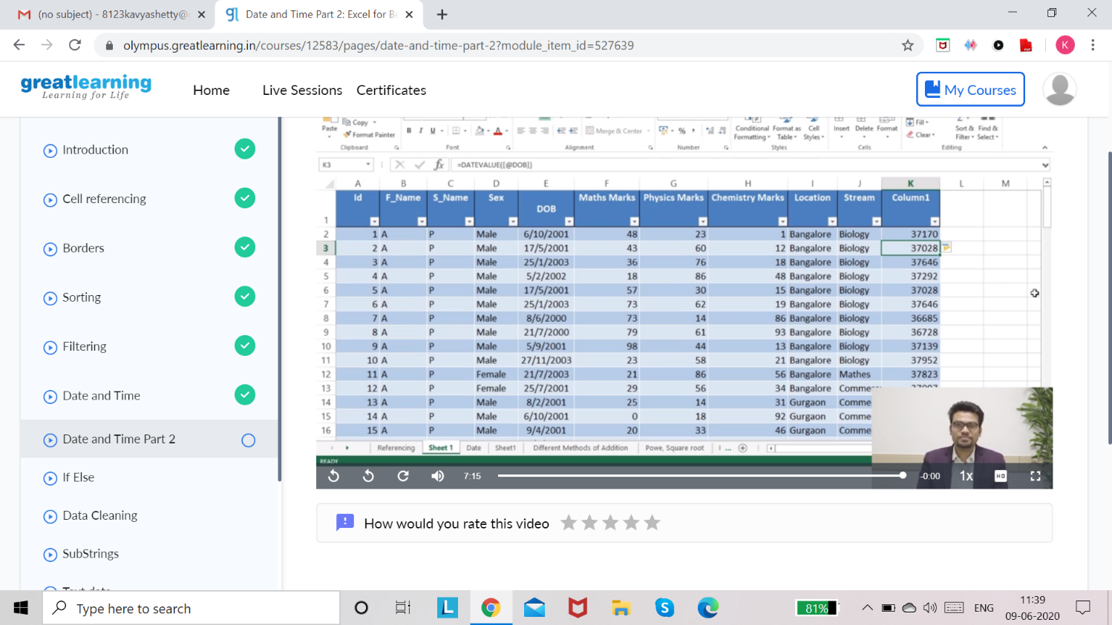

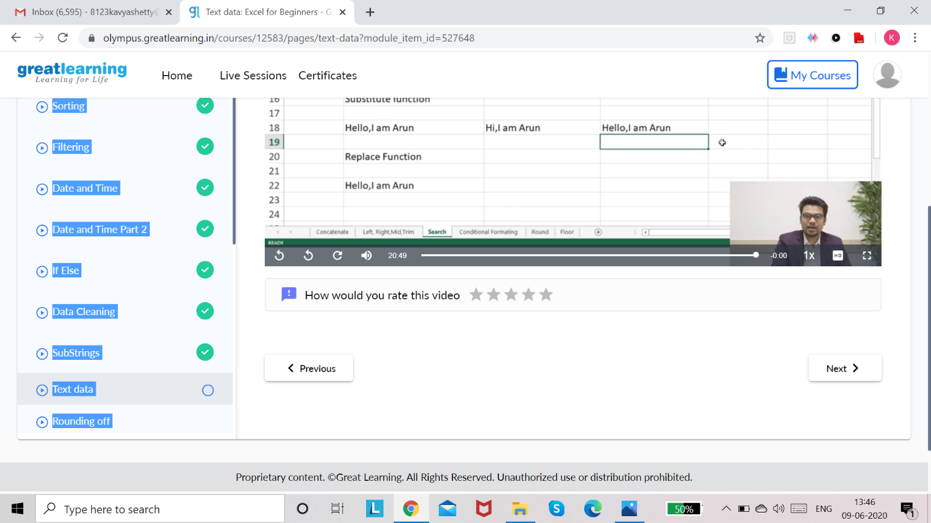

# Coding Challenge Details:

Refer the GitHub for Detailed Information:

<https://github.com/kavya-shetty765/DAILY-STATUS/tree/master/9-06-> [2020/ONLINE%20CODING](https://github.com/nandithashetty/DAILY-STATUS/tree/master/9-06-2020/ONLINE%20CODING)

The same report is also available in : <https://github.com/kavya-shetty765/DAILY-STATUS/tree/master/9-06-2020>